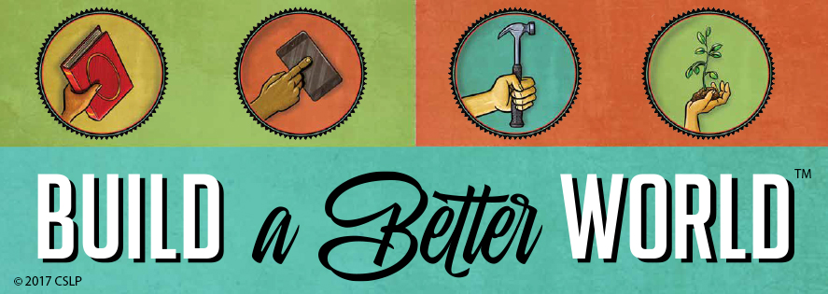
Summer Reading 2017 at the Walpole Town Library
Date | Activity | Time
Thursday June 29th | Kick Off Party | 2pm
Saturday July 1st | City Skylines Craft | 10am-12pm
Thursday July 6th | Nature Journals | 2-4pm
Saturday July 8th | Fleece Blankets for Animal Shelters | 10am-12pm
Tuesday July 11th | Kids Movie | 10am
Thursday July 13th | Wild Life Encounters | 2pm
Saturday July 15th | Crafts with Ms. Pickering | 10am-12pm
Thursday July 20th | Capes for Kids | 2-4pm
Saturday July 22nd | Edible Construction Trucks | 10am-12pm
Thursday July 27th | Butterfly Presentation & Craft | 2pm
Saturday July 29th | Cup & Block Challenge | 10am-12pm
Thursday August 3rd | Operation Gratitude Letters | 2-4pm
Saturday August 5th | Crafts with Ms. Pickering | 10am-12pm
Tuesday August 8th | Kids Movie | 10am
Thursday August 10th | Paint a Bird House | 2-4pm
Saturday August 12th | Duct Tape Bookmarks | 10am-12pm
Thursday August 17th | End of Summer Party | 2pm
If the time for a program is a range (i.e. 2-4pm or 10am-2pm) you’re welcome to stop in at any time. If the program has only a start time, please be here on time to enjoy the whole program.

Walpole Town Library 48 Main St. PO Box 367 Walpole, NH 03608 walpolelibrary@comcast.net 603.756.9806

